**BLOOD DONOR SOCIETY**

Software Requirement Engineering

|  |  |
| --- | --- |
| Roll no. | Name |
| Bsef20a0026 | Neha Noveed |
| Bsef20a036 | Aiza Naseer |
| Bsef20a048 | Komal Raza |

Group Name: Linkers

Group Members

D2

Group Idea: Blood Donor Society

**Requirements Traceability Matrix (RMT)**

|  |  |  |  |  |  |
| --- | --- | --- | --- | --- | --- |
| **Use case ID** | **Requirement Type** | **Requirement Name** | **Requirement**  **description** | **Status** | **Priority Scale(High, Medium, Low)** |
| **1.** | Business Requirements | 1.1) Project Need | 1.1.1) Receiver can track Donor location  1.1.2) Donor’s blood reports will be updated by Labs and Admin  1.1.3) Receivers will get donor information easily | Finished | High |
| 1.2) Benefit | 1.2.1) Easy access to the system by users  1.2.2) Better understanding (Urdu/English) for users  1.2.3) Connect with a secure and safe institute licensed by the health organization of Pakistan  1.2.4) Offline availability | Finished | High |
| 1.3) Implementation | 1.3.1) Tested for Bugs  1.3.2) Accuracy of Output  1.3.3)User-friendly | In Progress | High |
| **2.** | Functional Requirements | 2.1) Registration | User must have to register into the system to use the features | Implemented, Coded, Unit Tested | High |
| 2.1.1) Register as donor | If the user is register as donor then user must prove detail information (personal info, blood info, health info) | Implemented, Coded, Unit Tested | High |
| 2.1.2) Register as receiver | Is the user register as blood taker then user have to give personal info | Implemented, Coded, Unit Tested | High |
| 2.1.3) Validate account | Account must be verified by sending message to phone number by Admin | Implemented, Coded, Unit Tested | High |
| 2.2) Add request | Receiver send request to specify the blood group and needed units of blood | Implemented, Coded, Unit Tested | High |
| 2.3) Display request | Receiver request will be share and display to an appropriate donor | Implemented, Coded, Unit Tested | Medium |
| 2.3.1) Accept request | After viewing the request donor will accept request | Implemented, Coded, Unit Tested | High |
| 2.3.2) Reject and Shared | Donor may reject request due to any personal reasons and then request will be shared to other donors | Implemented, Coded, Unit Tested | High |
| 2.4) Track donor | Receiver can view donor location through GPS and the estimated time to reach the destination | Implemented, Coded, Unit Tested | Medium |
| 2.5) Previous request | User can see all previous requests as record | Implemented, Coded, Unit Tested | Low |
| 2.5.1) Delete request | After the successful blood transfusion, receiver will delete the request | Implemented, Coded, Unit Tested | Medium |
| 2.6) Manage reports | Donor’s medical reports will be store and manage in donor database | Implemented, Coded, Unit Tested | High |
| 2.6.1)verified blood test result | If the blood test results negative, then donors profile will be update but in case of positive blood test reports donor will be considered ineligible donor. that donor will not be able to accept request but can use other system features | Implemented, Coded, Unit Tested | High |
| 2.7) View statistical health chart | Donor can view his/her health status in a graphical form /statistical chart | In Progress | Medium |
| 2.8) History log | User can see his/her previous activities in history log | Implemented, Coded, Unit Tested | Low |
| 2.9) Log out | After successfully completion of user demand user will logout through the system | Implemented, Coded, Unit Tested | Medium |
| **3.** | Non-functional Requirements | 3.1) Usability | System can be used again and again without distortion | Implemented, Coded, Unit Tested | High |
| 3.2) Performance | 3.2.1) The system will give responses within 1 second after checking the donor information and other details  3.2.2) System support 1000 people at a time  3.2.3) 99% of the task will be performed in less than 1sec | Implemented, Coded, Unit Tested | High |
| 3.3) Security | System will maintain history logs and maintain security of logins and user database | Implemented, Coded, Unit Tested | High |
| 3.4) Safety | If system fails, recovery method restores a past copy of the database | Implemented, Coded, Unit Tested | High |
| 3.5) Accessibility | Access level is controlled for each user according to their work scope | Implemented, Coded, Unit Tested | Medium |
| 3.6) Availability | The system shall be available all the time | Implemented, Coded, Unit Tested | High |
| 3.7) Maintainability | The system will be maintained, have up-to-date information and policies of SBTP and BTA, updated fix problems of the system | Implemented, Coded, Unit Tested | High |
| 3.8) Stability | The system won’t change from time to time but may have updates | Implemented, Coded, Unit Tested | Medium |

Wireframes

Blood Donor Society

Registration > lab/hospital/blood bank

Registration

Home

Welcome page

Log in

Verification code will be send at the user contact number

Home

Home > drop down menu

Home > add request

Home

Home > become donor

After become donor user is able to search locations / address of any lab, hospital, blood bank or another user (donor, receiver)

Home-1

Home-1

Notify

User

Stats: display the statistical chart of all the register users detail (like total donations per year, total positive and negative blood test report, their health chart etc.) which can be used as survey and awareness purposes

Home-1

Stats

Chat

User

User > blood test

User > profile

User

User > health stats

User > remainder

User

User > setting

User > guide

**Use case Diagram**

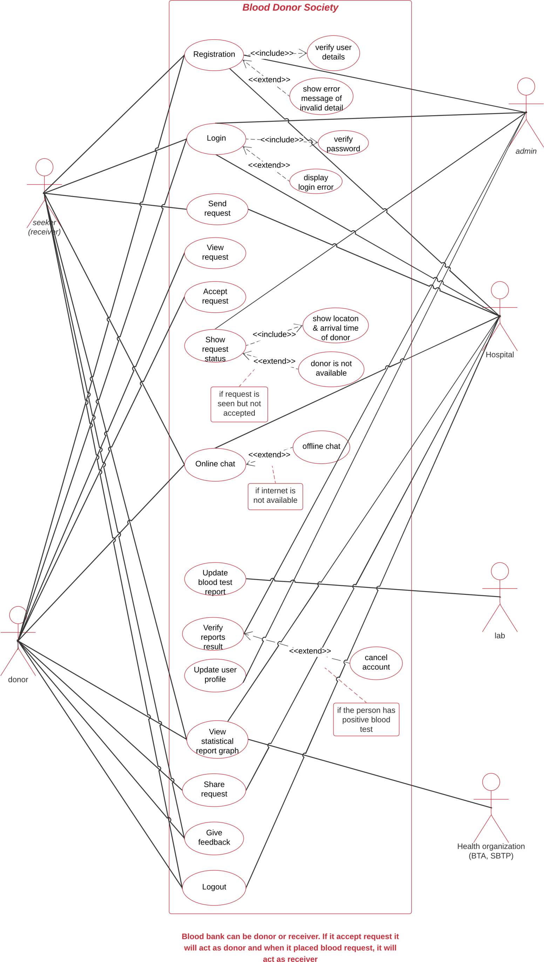 **Use case Descriptions**

# Use case 1: User Registration

|  |  |
| --- | --- |
| **ID and Name** | UC-1 Registration |
| **Primary Actors** | Seeker (receiver), Donor |
| **Secondary Actors** | Admin, Hospital |
| **Description** | User will register into the system and have to give personal info |
| **Trigger** | Verification code will be sent to user via number |
| **Preconditions** | **PRE-1** User selected the registration form to fill |
| **Post-conditions** | **POST-1** Information is valid. Saved in database  **POST-2** Invalid Information. Error message displayed |
| **Normal Flow** | 1. User will enter his/her phone number, CNIC, username and password for registration 2. User will agree on specified terms and policies 3. User will register himself/herself through phone number |
| **Alternative Flow** | **1**. User can also register himself through Google |
| **Exceptions** | 1. If the phone number of user is not valid then system will prompt an “Invalid phone number” message 2. If the password of user is not according to pattern of system, then system will prompt an incorrect pattern message |
| **Priority** | High |
| **Assumption** | It is assumed that all users are  authorized users. |

# Use case 2: Login

|  |  |
| --- | --- |
| **ID and Name** | UC-2 Login |
| **Primary Actors** | Seeker (receiver), Donor |
| **Secondary Actors** | Admin, Hospital |
| **Description** | User must log into the system in order to use it |
| **Trigger** | User indicates that they want to log in the system to receive or donate blood |
| **Preconditions** | **PRE-1** Users must register themselves before login  **PRE-2** Users must be authorized users |
| **Post-conditions** | **POST-1** After login, user can search for a blood and add request  **POST-2** User can accept blood request |
| **Normal Flow** | 1. User will enter his/her username, password and verification code 2. The password and username will be verified by the system |
| **Alternative Flow** | If the user forgets his/her password then he will be asked to reset the password |
| **Exceptions** | System will show the login error if users enter the wrong login credentials and will ask to re-enter login info |
| **Priority** | High |
| **Assumption** | We assume that the receiver or donor are authorized users and registered their account on app |

# Use case 3: Send Request

|  |  |
| --- | --- |
| **ID and Name** | UC-3 Send request |
| **Primary Actors** | Seeker (receiver) |
| **Secondary Actors** | Hospital |
| **Description** | Receiver send request to the donor to specify the blood group and units required |
| **Trigger** | Receiver request will be sent to an eligible donor in order to get blood units |
| **Preconditions** | **PRE-1** User must be logged in before sending the blood request  **PRE-2** User identity has been authenticated |
| **Post-conditions** | **POST-1** Request details will be sent to an eligible donor so he can view details |
| **Normal Flow** | Users enter the request details and it will send to an eligible donor. So, the donor can respond to the request |
| **Alternative Flow** | Receiver can search a donor and send requests manually |
| **Exceptions** | If request details are missing or incorrect then it will prompt an error message and will ask the requestor to enter details again |
| **Priority** | High |
| **Assumption** | Assume that the searched blood group is available. |

# Use case 5: Accept Request

|  |  |
| --- | --- |
| **ID and Name** | UC-5 Accept request |
| **Primary Actors** | Donor (Blood Bank) |
| **Description** | After viewing the request details donor will accept the request |
| **Trigger** | Donor will see the blood request details |
| **Preconditions** | **PRE-1** Donor will receive a blood request notification |
| **Post-conditions** | **POST-1** Receiver will be notified that his/her request is accepted |
| **Normal Flow** | Receiver will be notified that his/her request is accepted successfully |
| **Alternative Flow** | If the request is rejected then the system will send the blood request to another eligible donor |
| **Exceptions** | Due to slow internet user is not notified on time |
| **Priority** | High |
| **Assumption** | We assume that the donor blood matches with the desired blood. |

# Use case 8: Update Blood Test Report

|  |  |
| --- | --- |
| **ID and Name** | UC-8 Update Blood Test Report |
| **Secondary Actors** | Lab |
| **Description** | For updating blood test report |
| **Trigger** | Donor want to donate blood, so he/she must have negative blood test reports |
| **Preconditions** | **PRE-1** User (Donor) selects accept blood request |
| **Post-conditions** | **POST-1** Blood test report updated successfully |
| **Normal Flow** | Request accepted successfully if blood reports are negative |
| **Alternative Flow** | Blood request will be shared to other donors |
| **Exceptions** | Blood test reports will be confirmed by labs |
| **Priority** | High |
| **Assumption** | We assume that donor will soon reach to receiver |

# Use case 9: Verify Reports Result

|  |  |
| --- | --- |
| **ID and Name** | UC-9 Verify reports result |
| **Secondary Actors** | Admin |
| **Description** | For negative blood test reports |
| **Trigger** | Donor accepted blood request and have negative blood test reports |
| **Preconditions** | **Pre-1** Donor need to accept request  **Pre-2** Donor need to have blood test before donation and it must be negative |
| **Post-conditions** | **Post-1** Donor can donate blood |
| **Normal Flow** | If blood test reports are negative, then profile will be updated and donation details will be stored in database |
| **Alternative Flow** | If blood test reports are negative then the donor will be considered ineligible and blood request details will be shared |
| **Exceptions** | If examination session before the blood test is not cleared then blood test and donation won’t be conducted |
| **Priority** | High |
| **Assumption** | System will show donor’s location and arrival time |

# Use case 11: View Statistical Report Graph

|  |  |
| --- | --- |
| **ID and Name** | UC-11 View Statistical Report Graph |
| **Primary Actors** | Receiver, Donor |
| **Secondary Actors** | Hospital, Health organization (BTA, SBTP) |
| **Description** | When donors blood test reports are negative and his/her profile is updated |
| **Trigger** | User profile is updated |
| **Preconditions** | **PRE-1** Donor had blood test report |
| **Post-conditions** | **POST-1** Donor can view his/her health charts |
| **Normal Flow** | Donor will donate blood and receiver will receive |
| **Alternative Flow** | Request will be shared if donor is considered ineligible |
| **Exceptions** | System will show health chart |
| **Priority** | Medium |
| **Assumption** | Blood donation process is successful |

# Use case 12: Share Request

|  |  |
| --- | --- |
| **ID and Name** | UC-12 Share Request |
| **Primary Actors** | Donor |
| **Secondary Actors** | Hospital |
| **Description** | When first donor reports didn’t match request will be shared with other donors |
| **Trigger** | First donor didn’t donate blood or is ineligible |
| **Preconditions** | **PRE-1** Donor didn’t donate blood |
| **Post-conditions** | **POST-1** System will share request and will find another donor |
| **Normal Flow** | Second donor will accept request and donate blood |
| **Alternative Flow** | Find another donor if second didn’t match or is ineligible |
| **Exceptions** | System will show donor list |
| **Priority** | High |
| **Assumption** | Second blood donor matches and donate blood |

**Activity diagram**

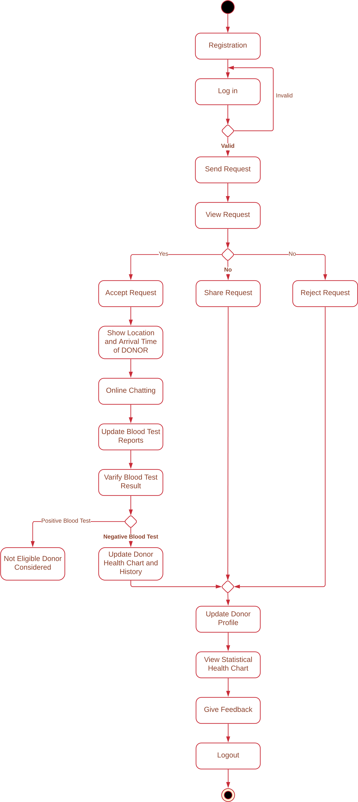

**DFD Level ~~–~~ 1**

